Protists Assignment

Use the cladogram on the next page to identify the major clades of these organisms. The major clades are the colored bars on the right side of the cladogram. Please note: If you use the 7th edition, you will get these wrong. The clade names have changed based on more recent research.

Organism | Major Clade
Euglena

Brown Algae

Volvox

Paramecium

Amoeba

Plasmodial slime mold

Diatoms

Red algae

Foraminiferans

Radiolarians

Dinoflagellates

Trypanosoma

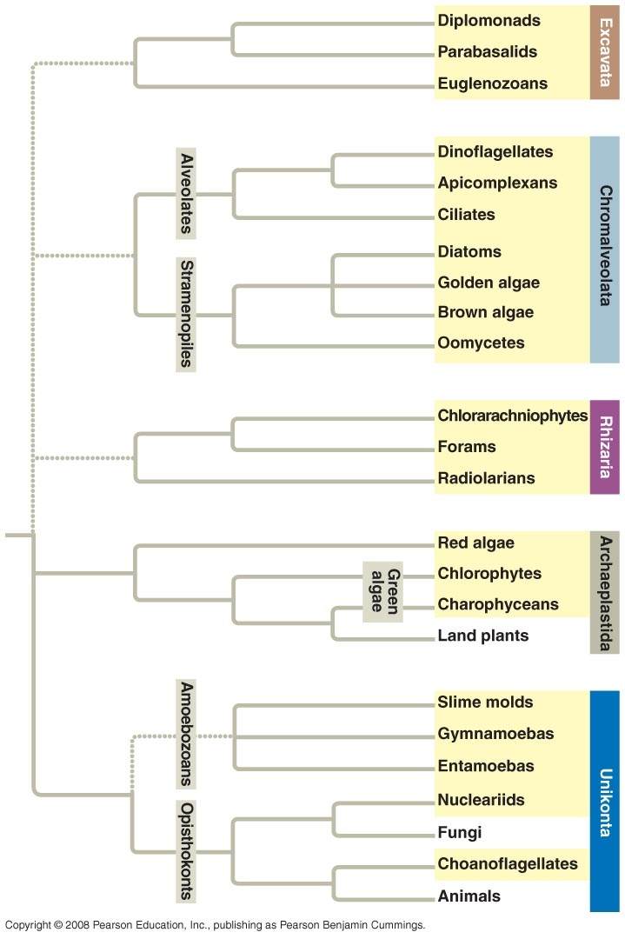

Use the cladogram on the previous page to answer these questions.

1. Look at the group called "Green Algae". Is this a monophyletic, paraphyletic or
polyphyletic group?

2. The Amoebozoans include which protist groups?

3. The charophyceans and land plants are most closely related to what group?

4. The Alveolates includes which protist groups?

5. The Stramenopiles include which protist groups?

Further Explorations

Malaria
Go to this website: http://discovermagazine.com/
Search for the free article: “Fighting the Parasite From Hell”.

1. How is malaria transmitted? Be specific.
2. What is the cause of the fevers and chills that occur every 48 hours?
3. How does malaria kill people? Be specific.
4. How does chloroquine work at the cellular level?
5. How has resistance to chloroquine evolved in some parasites?
6. Diagram the life cycle of the malaria parasite.
7. What anti-malarial drug did the Chinese discover? How does it work to defeat
malaria at the cellular level?
8. What are the advantages of combining artemisinin with another drug in the “two-
drug cocktail”? What is the disadvantage?
9. What are the varients of hemoglobin that help protect humans from malaria?

Phytoplankton
Go here: http://earthobservatory.nasa.gov/Library/Phytoplankton/phytoplankton2.html

1. Briefly explain the effect of phytoplankton on atmospheric temperature.

Go here: http://earthobservatory.nasa.gov/Library/Coccolithophores/
2. What structure is unique to coccolithophores? What material is used to make
this structure?
3. What do coccolithophores do with extra scales? How much is then available for
other organisms to use, per year? Why is this important to ocean ecosystems?

Go here: http://www.ucmp.berkeley.edu/chromista/diatoms/diatommm.html
http://www.ucmp.berkeley.edu/chromista/diatoms/diatomlh.html

4. What materials are used to make diatom skeletons?
5. Diatoms are abundant in which ecosystems?
6. What is the relationship between levels of carbon fixation and diatoms?
7. Why is sexual reproduction important for diatoms?

(Alice in Wonderland, Ch 2: “...she soon found out that the cause of this was the fan she was holding, and she dropped it hastily, just in time to avoid shrinking away altogether.”

Harmful Algal Blooms
Go here: http://www.whoi.edu/redtide/whathabs/whathabs.html
Click on the links to fish, birds, marine mammals and humans.

1. What is the difference between a red tide and a harmful algal bloom (HAB)?
2. Identify the specific toxin that killed 14 humpback whales off Cape Cod.
3. Identify the specific toxin that killed brown pelicans and cormorants near
Monterey Bay, CA.
4. What happened to the six fishermen who ate surf clams and why?

